**Software Architecture and Design**

**Software Architecture** typically refers to the bigger structures of a software system, and it deals with how multiple software processes cooperate to carry out their tasks.

**Software Design** refers to the smaller structures and it deals with the internal design of a single software process

The architecture of a system describes its major components, their relationships (structures), and how they interact with each other. Software architecture and design includes several contributory factors such as Business strategy, quality attributes, human dynamics, design, and IT environment.

1. Software Architecture

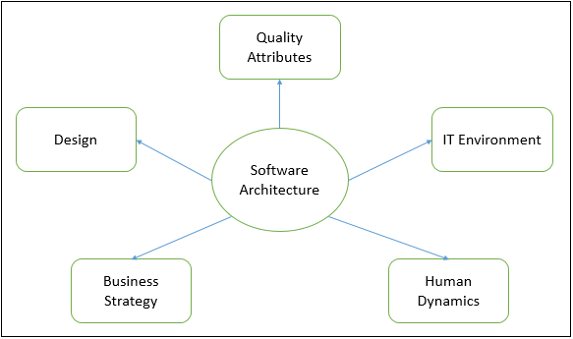

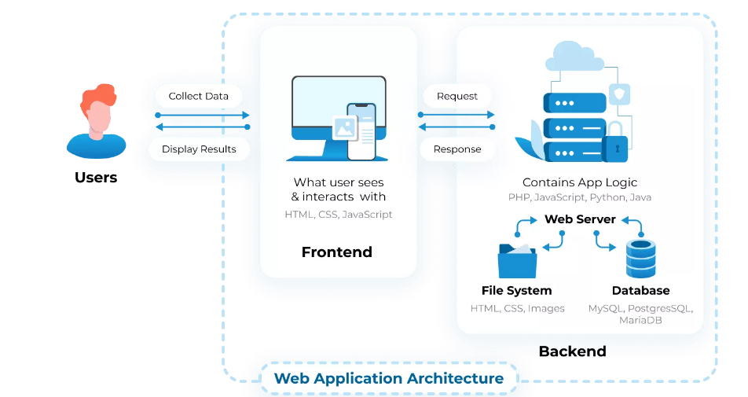

1. Software Design

